**Ensuring Horses Show Up on DEFHR Connector**

1. Select “Horses” from the Wordpress sidebar:

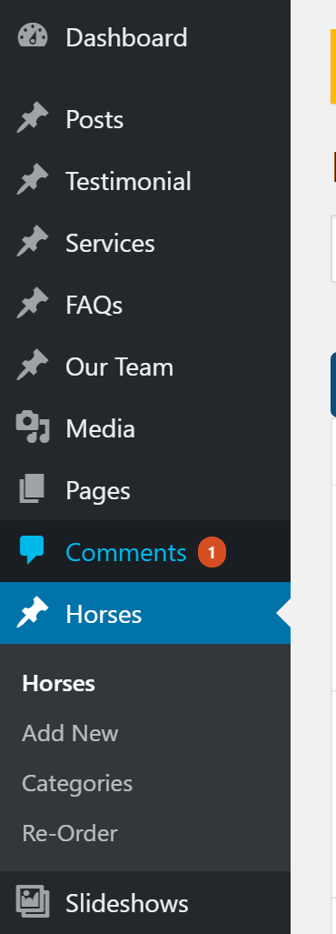

1. For each horse you want to appear on the DEFHR Connector, be sure the following fields are filled out:

* Name
* Status (must be set to “Available for Adoption”)
* Breed
* Sex
* Height
* Year of Birth
* Thumbnail (must have an image of resolution: 300x225px)

1. That’s it! You’re set! The horse should appear within 2-3 minutes on the DEFHR Connector site. If you have any problems, please contact me at [patrick.tisdel@icfi.com](mailto:patrick.tisdel@icfi.com) and I can troubleshoot your issue.